Enhancing the Extensions using Visual Claude Code
Assignment 1: Read DOM structure using Typescript & Playwright
Ask: Act as a senior architect and understand the entire current project. this will be helpful for further enhancement and code implementation
flowchart LR
A[User opens extension side panel] --> B[Select DOM via inspector]
B --> C[content.js collects outerHTML]
C --> D[background service worker stores snippet]
D --> E[chat.js builds prompt]
E --> F[LLM provider API: Groq/OpenAI/InceptionLabs]
F --> G[Generated Selenium/Cucumber code]
G --> H[Render markdown + copy actions in panel]
Plan: Currently the extension setting have the implementation of Java language with Selenium browser engine which can read the Dom structure. in a similar way want to read the Dom structure using language as Typescript and Playwright as Browser engine

Ask : Proceed with the implementation

Output:
✅ TypeScript + Playwright support added
I implemented the missing DOM-generation path so the extension now recognizes:
- Java + Selenium
- TypeScript + Playwright
and preserves the existing Java/Selenium flow.
Updated files
- Phase 1/Week 3/Day 1_Browser Extension/ai-extension-inception-ui updated (1)/ai-extension-updated/src/scripts/prompts.js/ai-extension-updated/src/scripts/prompts.js)
- Phase 1/Week 3/Day 1_Browser Extension/ai-extension-inception-ui updated (1)/ai-extension-updated/src/scripts/chat.js/ai-extension-updated/src/scripts/chat.js)
What changed
- Added a new prompt template: PLAYWRIGHT_TS_PAGE_ONLY
- Added the generator mapping in CODE_GENERATOR_TYPES
- Updated the selection logic so TypeScript + Playwright is treated as supported
- Kept the Java/Selenium support untouched
Verification
I checked the edited files with the workspace diagnostics tool, and it reported:
- No errors in src/scripts/chat.js/ai-extension-updated/src/scripts/chat.js)
- No errors in src/scripts/prompts.js/ai-extension-updated/src/scripts/prompts.js)
This gives you the exact root-cause fix for the supported generation checks; the DOM inspection logic itself was already generic and did not need a change.
If you want, I can next help you add the actual Playwright page object generation prompt examples more aggressively for forms, tables, and modals, or wire in the UI text so the settings clearly display “TypeScript + Playwright” as a supported path.

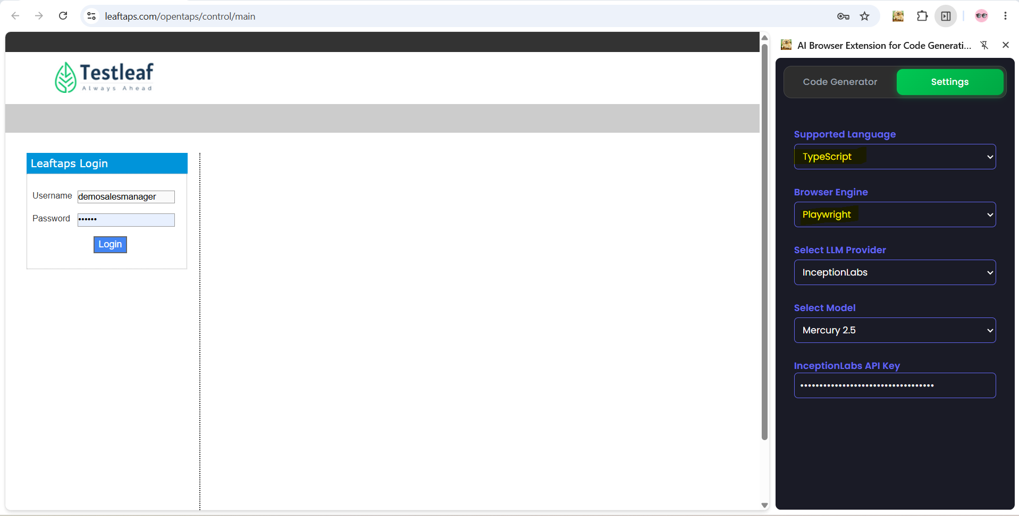
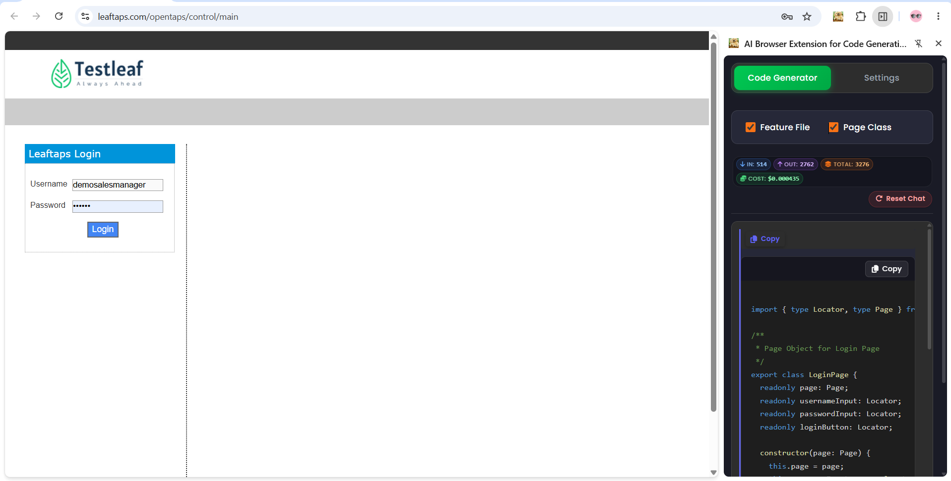

import { type Locator, type Page } from '@playwright/test';

/**
* Page Object for Login Page
*/
export class LoginPage {
readonly page: Page;
readonly usernameInput: Locator;
readonly passwordInput: Locator;
readonly loginButton: Locator;

constructor(page: Page) {
this.page = page;
this.usernameInput = page.locator('#username');
this.passwordInput = page.locator('#password');
this.loginButton = page.getByRole('button', { name: 'Login' });
}

/**
* Fills the username input field
* @param username - The username value to enter
*/
async fillUsername(username: string): Promise<void> {
await this.usernameInput.fill(username);
}

/**
* Fills the password input field
* @param password - The password value to enter
*/
async fillPassword(password: string): Promise<void> {
await this.passwordInput.fill(password);
}

/**
* Clicks the login button to submit the form
*/
async clickLogin(): Promise<void> {
await this.loginButton.click();
}
}

Assignment 2: Add one more model in Model selection dropdown
Ask : Ask: There are 3 models available under Select Model dropdown in the Settings tab. I want to add one more model. Analyse the code and provide me the class and function where i need to update the code
Plan: Enhance without any impact on the existing code by including model value and label for groq Value/Label: openai/gpt-oss-safeguard-20b
Before implementation :
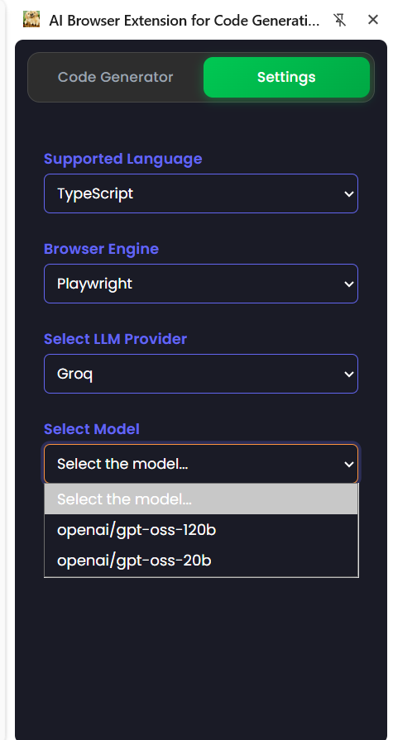

Plan analyse output:
Exact update location for the new Groq model
This is not a class-based change; it is a data-driven dropdown configuration in the settings UI.
- The model list is defined in Phase 1/Week 3/Day 1_Browser Extension/ai-extension-inception-ui updated (1)/ai-extension-updated/src/scripts/popup.js/ai-extension-updated/src/scripts/popup.js)
- The relevant object is modelsByProvider
- The function that builds the dropdown options is updateModelOptions(provider)
Where to add the new entry
Inside the groq array in modelsByProvider, add:
- value: openai/gpt-oss-safeguard-20b
- label: openai/gpt-oss-safeguard-20b
This is the exact low-risk insertion point because the rest of the settings flow already reads from that registry.

Why this is the right place
The dropdown is populated from the provider map, not from a hardcoded HTML list. So changing the Groq array is enough to surface the new model in the Select Model dropdown without impacting the existing Java/Selenium or TypeScript/Playwright logic.
The flow is:
- modelsByProvider in popup.js/ai-extension-updated/src/scripts/popup.js)
- updateModelOptions(provider) in the same file
- selected value is saved and used by the app later

Optional pricing update
If you also want the model to be recognized in cost calculations, add the same value to the Groq section in:
- Phase 1/Week 3/Day 1_Browser Extension/ai-extension-inception-ui updated (1)/ai-extension-updated/src/config/pricing.js/ai-extension-updated/src/config/pricing.js)
Relevant symbols:
- PRICING
- calculateCost(provider, model, inputTokens, outputTokens)
This is optional and does not affect generation behavior; it only affects pricing/cost display.

Recommended change scope
- Include only the new Groq model in modelsByProvider.groq
- Leave prompts, generation paths, and provider logic untouched
- Optionally add pricing metadata only if cost reporting should include the new model
This is the safest enhancement with no impact on the existing code.

Agent : Continue with the implementation
Agent output:
Implementation complete
Added the new Groq model to popup.js:
- Value: openai/gpt-oss-safeguard-20b
- Label: openai/gpt-oss-safeguard-20b
Validation completed successfully:
- No JavaScript diagnostics found.
- Existing provider and model-selection logic remains unchanged.
- Pricing metadata was not modified because no pricing details were provided.
Post Implementation:
